**Activity 1: To-Do List API + UI**

This is a modern take on the traditional To-Do list on paper, it focuses on simplicity and functionality. This helps you stay on top of your daily activities. You can quickly add new tasks, update them when plans change, mark items as complete with a simple checkbox, or remove them when they’re no longer needed. Designed with a clean and vibrant interface, it makes organizing your schedule both practical and visually engaging.

**Members:**

Patrick Raymond P. Benito

Althea Dela Cruz

Ivan Louis D. Cielo

Filbert B. Dela Cruz

Justin Carl V. De Leon

**Visual Overview**

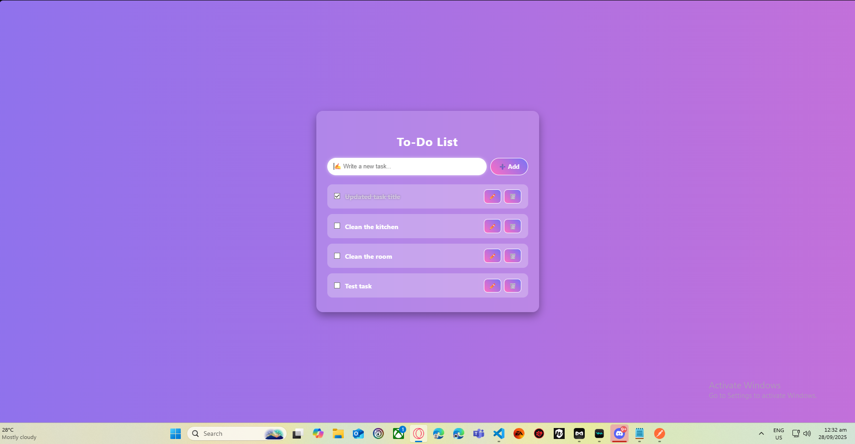

**Steps in showing functionality:**

1. Adding a task.

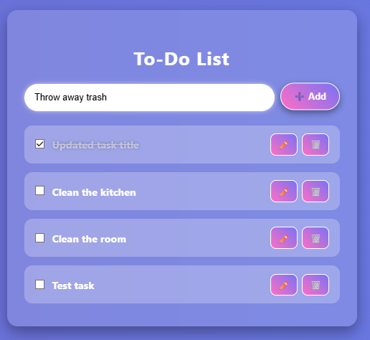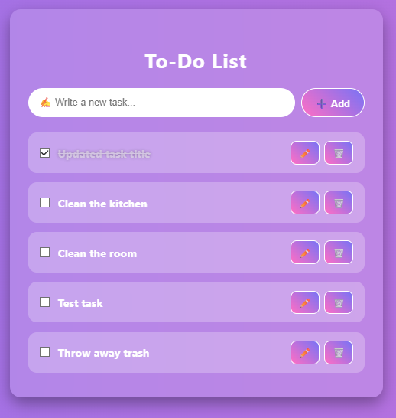

2. Ticking the checkbox when the task is finished.

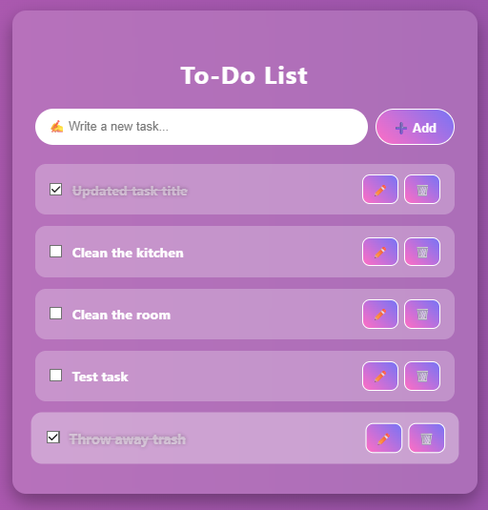

3. Editing a task

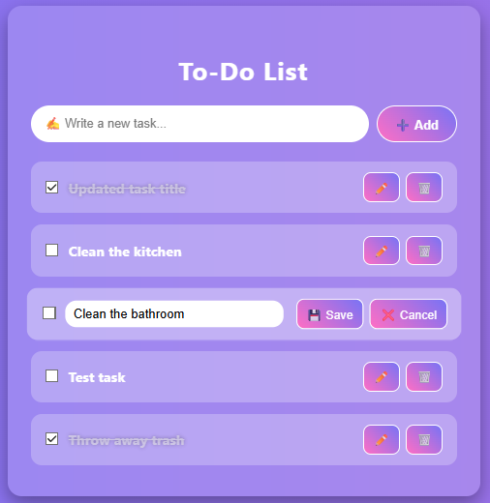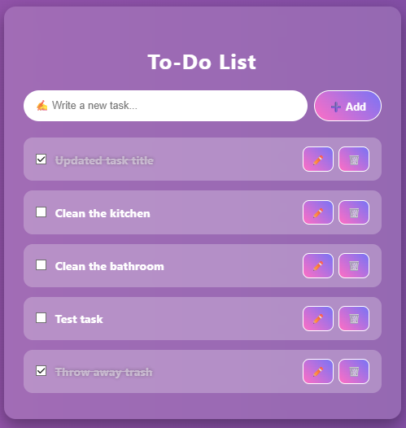

4. Deleting a task

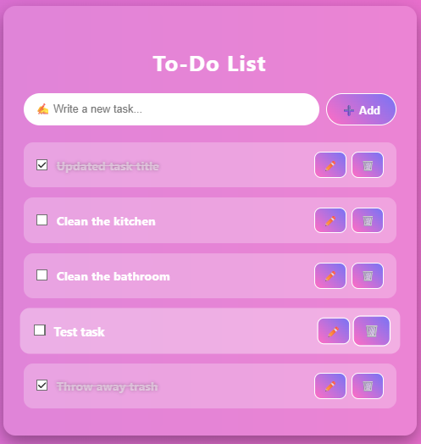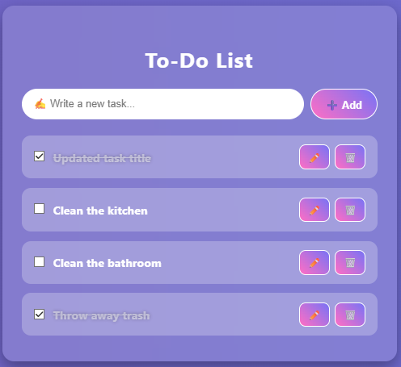

**API Connectivity Testing:**

1. Create (POST) - this will create a new task.

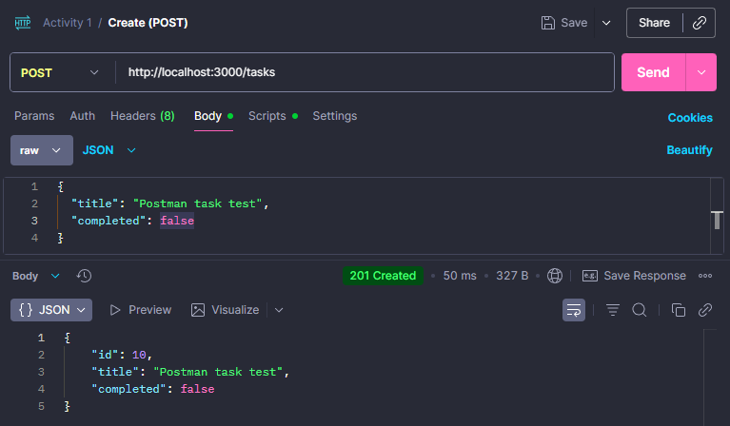

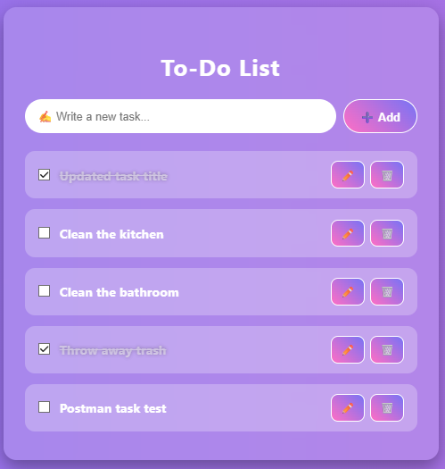

2. Read (GET one) & (GET all) - this calls a specific or all tasks.

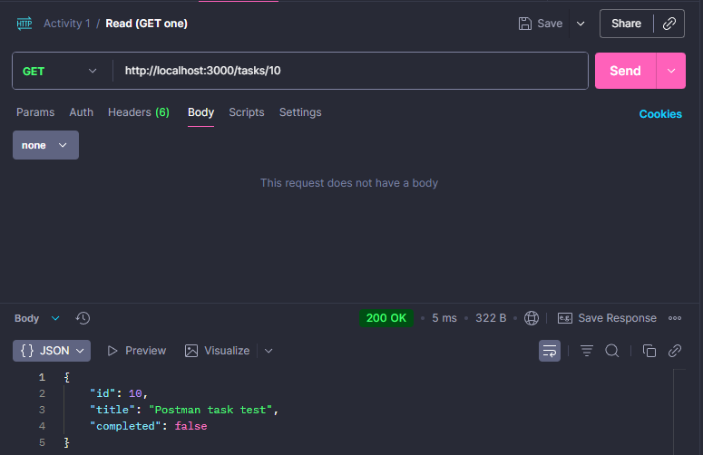

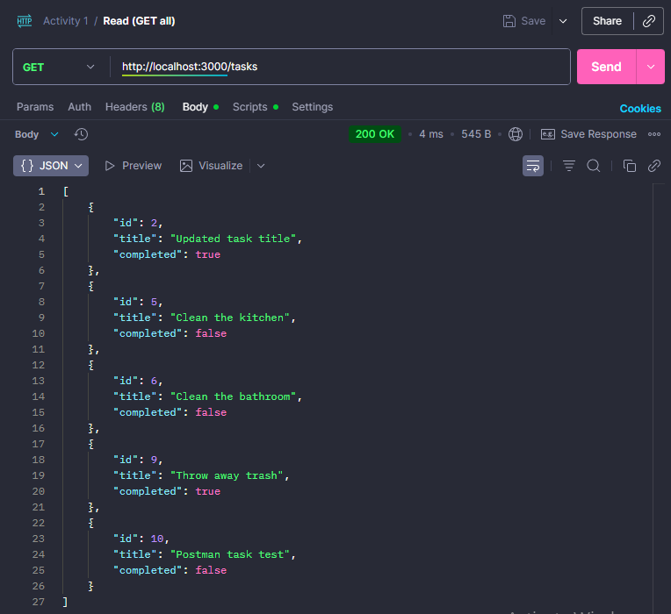

3. Update (PUT) - updates a task name and status.

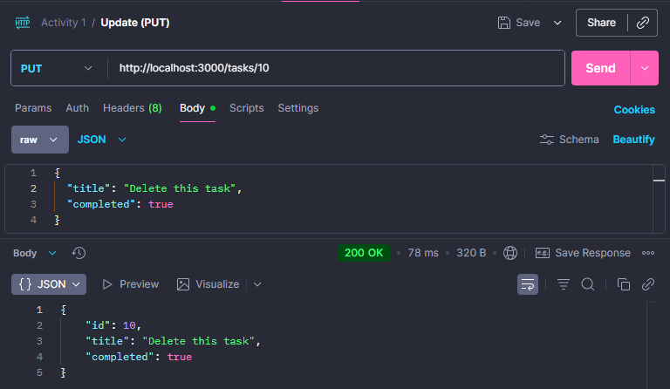

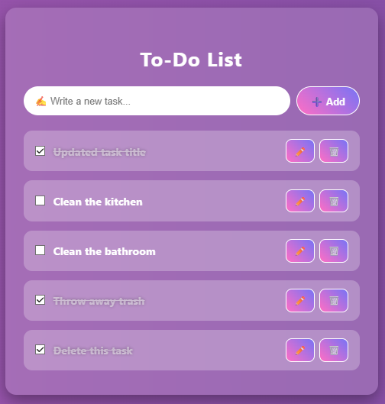

4. Delete (DELETE) - this deletes a task.

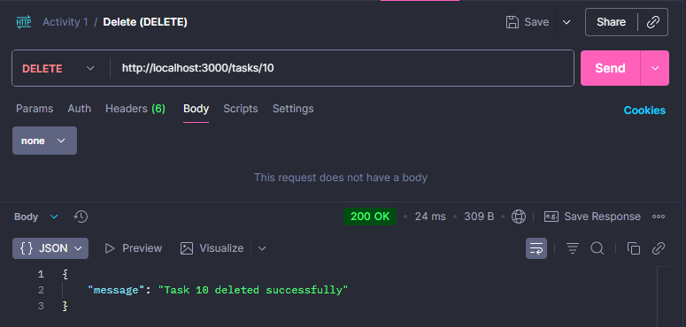

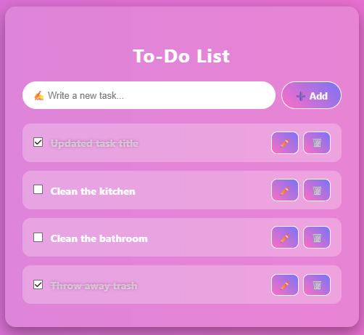

**Instructions to run the project:**

**1.** **Clone the repository**

git clone <https://github.com/chimken-adobo/Laboratory-Activities.git>

cd Activity 1 Folder

**2.** **Start the Back-End (NestJS API)**

**-Go into the backend folder**

cd act1backend

**-Install dependencies**

npm install

**-Start the NestJS server**

npm run start

**3. Start the Front-End (React App)**

1. **Open a new terminal and go into the React front-end folder**

cd activity1

**-Install dependencies**

npm install

**Start the React app**

npm start

**Note:** After starting the Front-end it will ask this: Would you like to run the app on another port instead? » (Y/n)

Just press Y

⚠️IMPORTANT⚠️

IF THIS POPS UP WHEN INSTALLING "To address all issues (including breaking changes), run:

npm audit fix --force"

**\*\*DON'T DO IT\*\***.

Now if you accidentally did it, you need to follow these steps to fix it.

**\*\*Inside Bash\*\***

* 1. In your front-end folder (activity1):

rm -rf node_modules package-lock.json

* 2. Reinstall react-scripts manually, Since it’s missing or broken, install the exact version your project expects:

npm install react-scripts@5.0.1 --save

* 3. Reinstall everything else

npm install

* 4. Start the app again

npm start